Question 2 — StatefulSet with Init Container and Per-Pod Storage

- StatefulSet Status
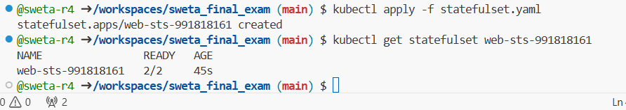

- Pods Running
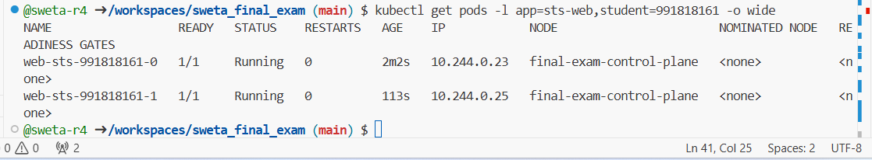

- Headless Service
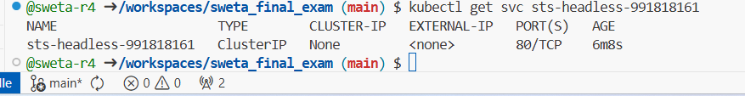

- PVCs (Per-Pod Storage)
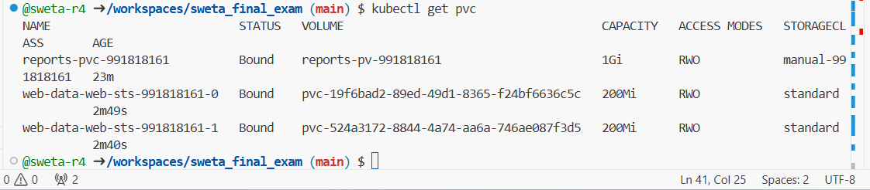

- DNS Check Pod Status
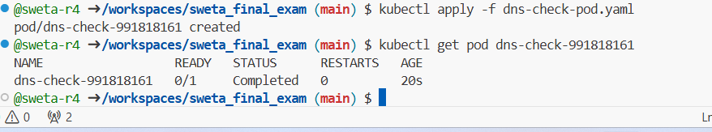

- DNS Check Logs
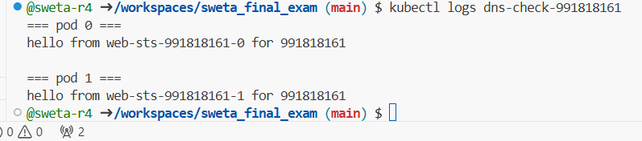

I created a headless Service and a StatefulSet with two replicas using volumeClaimTemplates to give each Pod its own persistent storage. An init container ran before nginx to seed an HTML file containing each Pod's unique hostname. A debug Pod verified that each StatefulSet Pod serves different content via stable DNS names, proving init containers, per-Pod PVCs, and headless Service DNS resolution work correctly.

YAML Manifests Used

